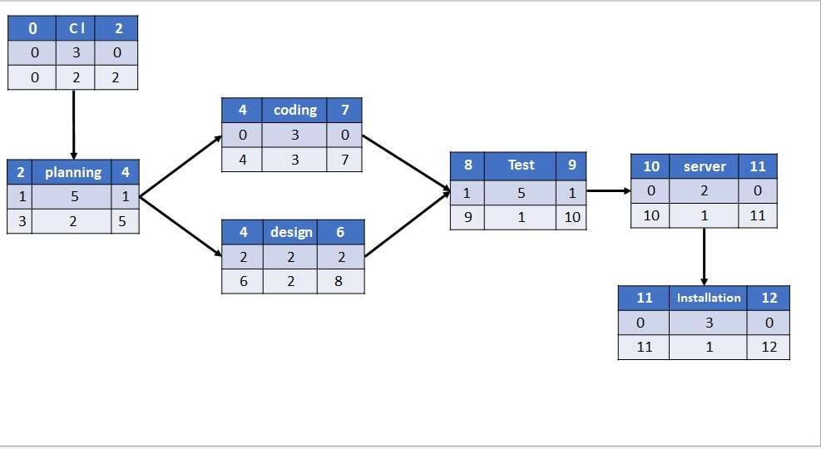**Automated warehouse network**

**Resource Constrained Schedule**

|  |  |  |  |  |  |  |  |  |  |  |  |  |  |  |  |  |  |
| --- | --- | --- | --- | --- | --- | --- | --- | --- | --- | --- | --- | --- | --- | --- | --- | --- | --- |
| task –  week | RES | DUR | ES | LF | SL | 1 | 2 | 3 | 4 | 5 | 6 | 7 | 8 | 9 | 10 | 11 | 12 |
| Collection data | 3 | 2 | 0 | 2 | 0 | 3 | 3 |  |  |  |  |  |  |  |  |  |  |
| Planning | 5 | 2 | 2 | 5 | 1 |  |  | 5 | 5 |  |  |  |  |  |  |  |  |
| Coding | 3 | 3 | 4 | 7 | 0 |  |  |  |  | 3 | 3 | 3 |  |  |  |  |  |
| Design | 2 | 2 | 4 | 8 | 2 |  |  |  |  |  | 2 | 2 |  |  |  |  |  |
| Test | 5 | 1 | 8 | 9 | 1 |  |  |  |  |  |  |  | 5 |  |  |  |  |
| Server | 2 | 1 | 9 | 10 | 0 |  |  |  |  |  |  |  |  | 2 |  |  |  |
| Installing | 3 | 1 | 10 | 11 | 0 |  |  |  |  |  |  |  |  |  | 3 |  |  |
| Resource Scheduled | | | | | | 3 | 3 | 5 | 5 | 3 | 5 | 5 | 5 | 2 | 3 |  |  |
| Resource Available | | | | | | 5 | 5 | 5 | 5 | 5 | 5 | 5 | 5 | 5 | 5 | 5 | 5 |